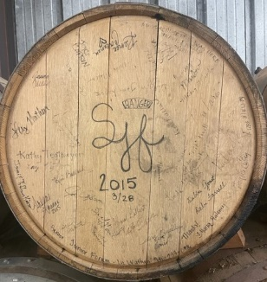
“TAP THE BARREL”
OCTOBER 1ST 6:30 to 9:30pm
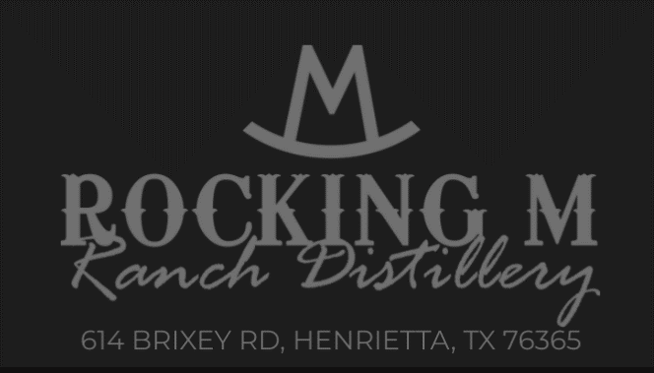
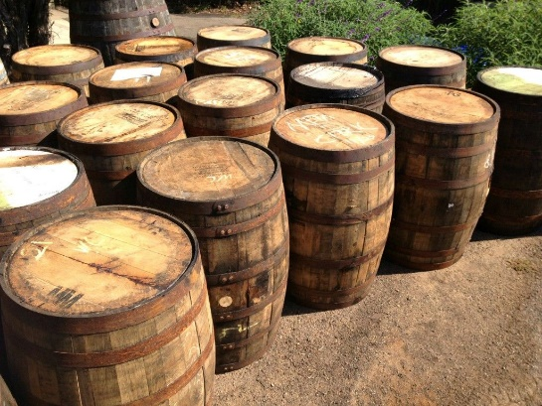

MEMBERS + 1 GUEST ** COST $40 per person
LIMIT TO 40 / PLUS WAITING LIST
DEADLINE TO SIGN UP **** SEPTEMBER 22 by 5PM
APPETIZERS * “OPEN TABLE” from Henrietta
CAN’T BRING ALCOHOL TO THE EVENT.
There will be a tasting & tour of the Distillery with drink samples plus eating and visiting. Go to the website & see the favors of Whiskey, Bourbon, Vodka, & Sipping Shine.
Later the Senior/Junior Forum “Barrel from 2015” will be tapped and tasted plus bottles can be purchased from this barrel.
RSVP TEXT WITH NAMES: ROMA 940-224-9312

