GAME NIGHT/JANUARY 20, 2022
6:00 PM / $22.00
ELKS LODGE: 4205 SEYMOUR HWY.

THE NIGHT OF GAMES, FOOD AND DRINKS!
MEMBERS + Lady Guest

MENU: Hamburger’s w/fixings, Fries and Cookies
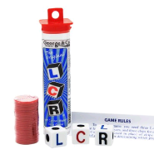
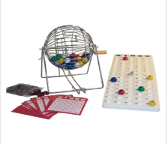
GAMES: Bingo, LCR
PRIZES: Gift Cards
2 DRINKS TICKETS
Please bring extra money for drinks & tips

DEADLINE: JAN. 12th……. RSVP/ TEXT
Roma Martin 940-224-9312

