GAME NIGHT / JANUARY 16TH

6:00 PM / $20.00
ELKS LODGE: 4205 SEYMOUR HWY.

THE NIGHT OF GAMES, FOOD AND DRINKS!
MEMBERS & GUESTS
MENU: Hamburgers to order plus extras
GAMES: Bingo, LCR
PRIZES: Gift Cards
Bring money for your drinks, there is a full bar.

Deadline is Jan. 9th Call or text
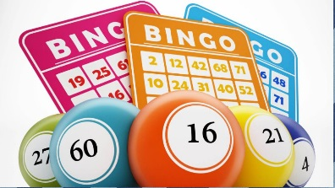
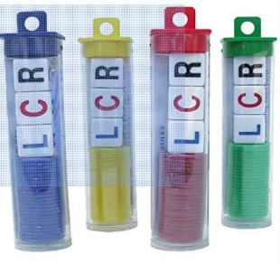
ROMA MARTIN 940-224-9312

